 | Student Name _______________________  Eastern Goldfields College  Mathematics Essentials 2015  Investigation 2 – Room Renovation
DUE DATE: _____________________________ TOTAL MARKS: 30
This investigation is a take-home task worth 5% of your semester mark.
You have been assigned ROOM 4 and the dimensions of the room are shown below.
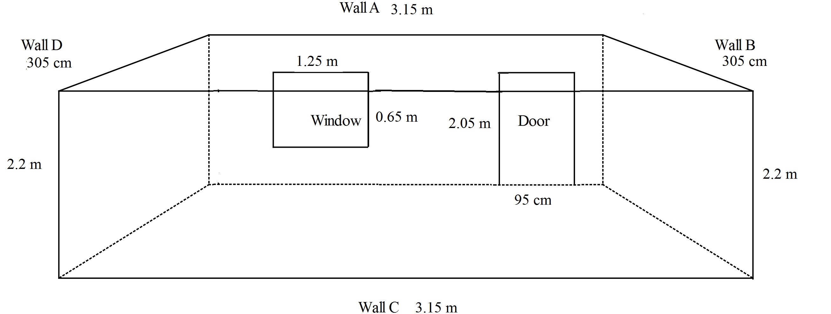

You must calculate the total cost of the room renovation by completing the questions given.

Question 1 Calculate the area of the door. (2 marks)

Question 2 Calculate the area of the window. (2 marks)

Question 3 a) Calculate the area of each wall in the room. To complete this question:
- Draw a diagram of each wall, including its dimensions. (2 marks)
- Show all your working out so that your answer can be checked. (8 marks)
- Be careful with Wall A – do not include the door and window in your answer.

b) What is the total area of the walls? (1 mark)

Question 4 The frame around the door is wooden.
- What length is needed to replace the frame around the door? (2 marks)

- If you have been quoted $11 per metre, what would it cost to buy the wood for the frame? (2 marks)

Question 5 Skirting board is a decorative edge that goes around the bottom of the room, where the wall meets the floor.
- What length of skirting board is needed to go around the room? (2 marks)

- What will this cost at $4.80 per metre? (1 mark)

Question 6 You need to paint the walls in your room. 4L of Dulux Wash & Wear costs $76.50 and covers 64 m². 2L of Dulux Wash & Wear costs $50.90 and covers 32 m².
- How much paint will you need to do two coats? (2 marks)

- Calculate the cost of painting the room. (1 mark)

Question 7 The renovation for this room will be the new frame around the door, the skirting board and the re-painting of the room with 2 coats. What is the total cost of the room renovation?
(2 marks)

Question 8 Americans use imperial measures, for example feet and inches. (3marks)
a) What is an inch in centimetres? One inch = _______________ cm

b) What is the height of the door in inches?

